Task 4: A) **Analyze sales data at a more detailed level (from region to product level)** :

Output:

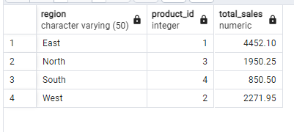

B) **Summarize sales data at different levels of granularity (from product to region level)**

Output

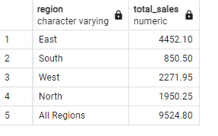

C) **Analyze sales data from multiple dimensions simultaneously**

Output:

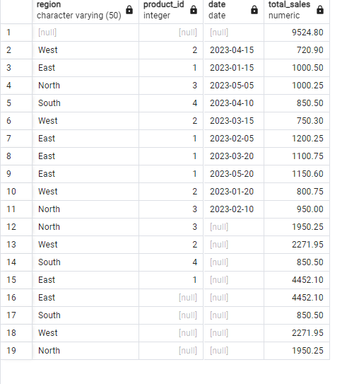

D) **Extract a subset of data based on specific criteria (for a particular region or date range)**

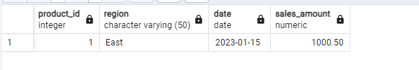

E) **Extract data based on multiple criteria (for specific combinations of product, region, and date)**

